**Assignment – 5**

Name- Yashraj Ranjeet Shitole

Roll no. - 86633

1) Write a query that will give you all orders for more than Rs. 1,000.

**SELECT * FROM Orders WHERE AMT > 1000;**

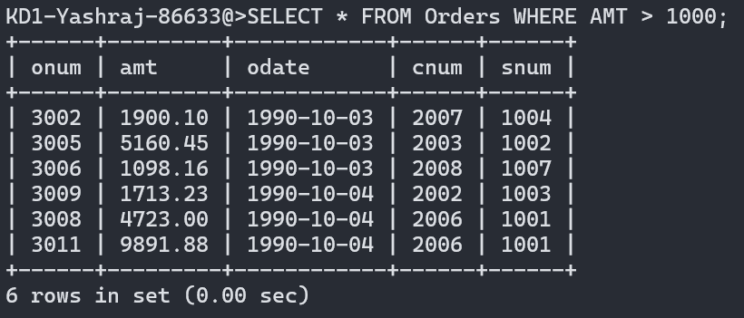

2) Write a query that will give you the names and cities of all salespeople in London with a commission above .10.

**SELECT * FROM Salespeople WHERE City = 'London' and COMM > 0.10;**

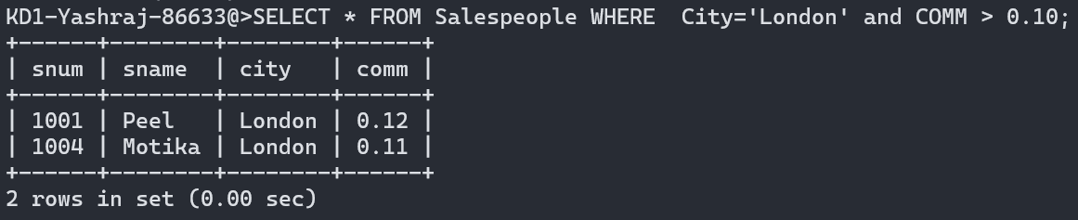

3) Write a query on the Customers table whose output will exclude all customers with a rating <= 100, unless they are located in Rome.

**SELECT * FROM Customers WHERE Rating > 100 or City ='Rome' ;**

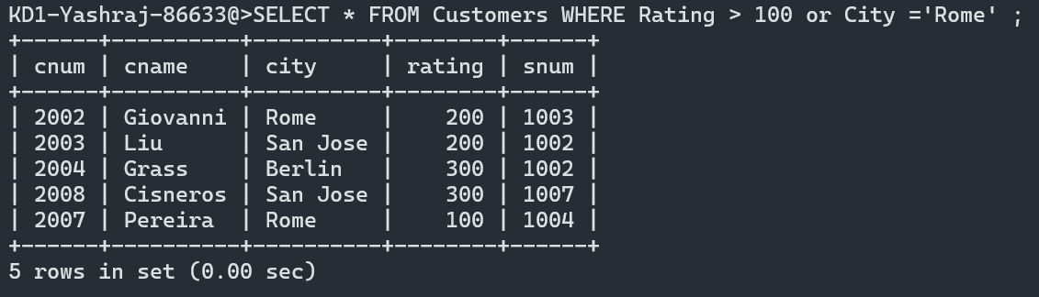

4) What will be the output from the following query?

**Select * from Orders where (amt < 1000 OR NOT (odate = ‘1990-10-03’ AND cnum > 2003));**

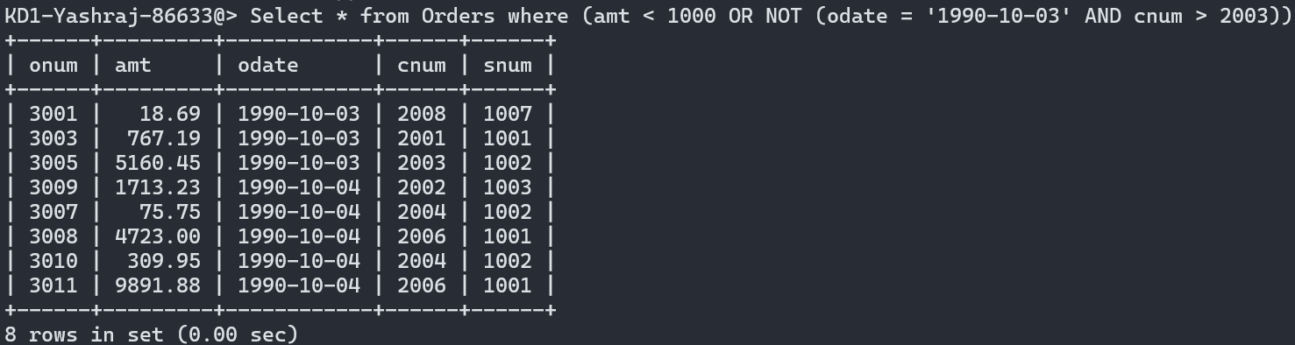

5) What will be the output of the following query?

**Select * from Orders where NOT ((odate = ‘1990-10-03’ OR snum >1006) AND amt >= 1500);**

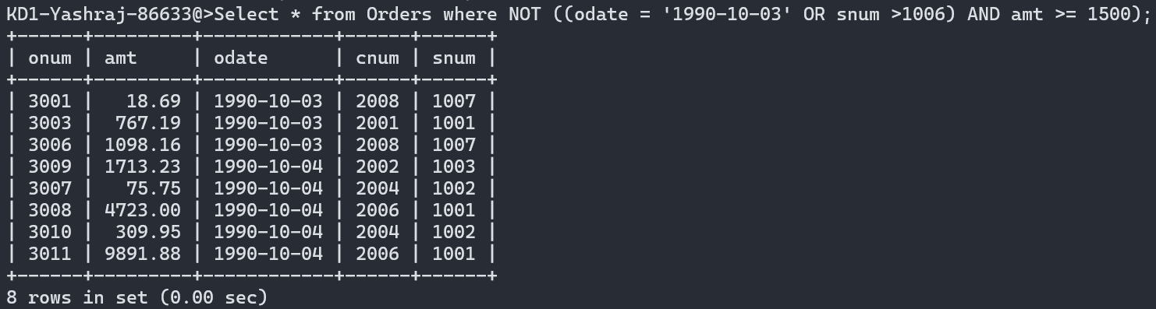

6) What is a simpler way to write this query?

**Select snum, sname, city, comm From Salespeople where (comm > .12 OR comm <.14);**

**Ans: SELECT snum, sname, city, comm FROM Salespeople;**